**CCNA**

Module- N+

Assignment

NAME : ASODARIYA VARUN PARESHBHAI

SUBJECT : NETWORK FUNDAMENTALS AND BUILDING NETWORK

**Assignment: Network Fundamentals and Building Network**

**Section 1: Multiple Choice**

1] What is primary function of a router in a computer network?

Ans: (C) Forwarding data packets between networks.

2] What is the purpose of DHCP (dynamic Host Configuration) in a computer network?

Ans: (D) Dynamically assigning IP addresses.

3] Which network topology connects all devices in a linear fashion, with each device connected to a central cable or backbone?

Ans: (B)Bus

4] Which network device operates at layer 2 (Data link layer) of the OSI model and forwards data packets based on MAC addresses?

Ans: (B)Switch

**Section 2: True or False**

5] A VLAN (Virtual local area network) allows network administrators to logically segment a single physical network into multiple virtual networks, each with its own broadcast domain.

Ans: True

6] TCP (Transmission control protocol) is a connectionless protocol that provides reliable, ordered, and error-checked delivery of data packets over a network.

Ans: False

7] A firewall is a hardware or software-based security system that monitors and controls incoming and outgoing network traffic based on predetermined security rules.

Ans: True

**Section 3: Short answer**

8] Describe the steps involved in setting up a wireless network of a small office or home office (SOHO) environment.

Ans.

DIAGRAM OF SOHO NETWORK….

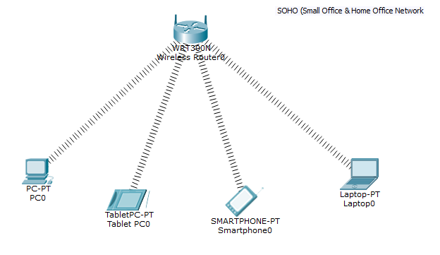

• **Open Cisco Packet Tracer**: Launch the Cisco Packet Tracer application on your computer.

**Select Devices**: choose a wireless router model suitable for SOHO environments.

**Connect Devices**: Add other devices such as computers or laptops to the workspace. Connect these devices to the wireless router using appropriate cables. For wireless connections.

**Access Router Configuration**: Double-click on the wireless router to access its configuration interface.

**Configure LAN Settings**:

Set the LAN IP address: Configure the LAN interface of the router with an appropriate IP address and subnet mask for your SOHO network.

Enable DHCP: Enable DHCP on the router to automatically assign IP addresses to devices connected to the LAN.

**MAC Filtering** **Settings**:

- Go to the wireless section

- Enable MAC filtering to start using this feature.

- Add Allowed Devices: You can add MAC addresses of devices that you want to allow

to connect to your network. Typically, you'll find an option to manually enter MAC addresses or select devices from a list of connected devices.

- Block Unwanted Devices: Optionally, you can block specific devices by adding their

MAC addresses to a blacklist.

**Firmware update**

Locate the latest firmware version available for your router model and download it to your computer. Make sure to download the correct firmware version to match your router model and hardware revision.

**Save Configuration**: Save the configuration of the router to apply the changes.

AND YOUR ROUTER IS READY FOR WIRELESS SOHO NETWORK.

9] Demonstrate how to configure a router for Internet access using DHCP  
(Dynamic Host Configuration Protocol).

**Finding Your Router's Address**

1. Connect Your Computer to the Internet:

Ensure your computer is connected to your router via Wi-Fi or Ethernet cable. If Wi-Fi isn't working, use an Ethernet cable to connect directly to the router.

1. Open Command Prompt:

Press Win + R to open the Run dialog box.

Type cmd and press Enter to open Command Prompt.

1. Get the Default Gateway Address:

In the Command Prompt, type ipconfig and press Enter.

Look for the line labeled Default Gateway under your network connection. This number is your router's IP address (e.g., 192.168.1.1).

1. Open a Web Browser:

Open any web browser (e.g., Chrome, Firefox, Edge).

1. Log In to the Router:

Password: admin or password

DHCP Configuration

1. Go into the config mode.
2. Create a new DHCP pool with the Ip dhcp pool NAME command
3. Define the default gateway with the default-router IP command
4. Define a subnet that will be used to assign IP addresses to hosts with the network SUBNET SUBNET_MASK command.
5. Define the DNS server with the dns-server IP address command.
6. Go into the config mode.  
   Router#**configure terminal**
7. Create a new DHCP pool with the ip dhcp pool NAME command  
   Router(config)#**ip dhcp pool VARUN DHCP**
8. Define a subnet that will be used to assign IP addresses to hosts with the network SUBNET SUBNET_MASK command.  
   Router(dhcp-config)#**network 192.168.0.0 255.255.255.0**
9. Define the DNS server with the dns-server IP address command.  
   Router(dhcp-config)#**dns-server 192.168.0.1**
10. Return to privilege config mode  
    Router(dhcp-config)#**exit**

**Section 4: Essay**

10] Discuss the importance of network documentation in the context of building and managing networks.

Ans.

**IMPORTANACE OF DOCUMENTATION IN THE CONTEXT OF BUILDING AND MANAGING NETWORKS**

Documentation is crucial for building and managing networks. It facilitates communication, troubleshooting, change management, disaster recovery, security, compliance, capacity planning, performance optimization, and knowledge transfer. With comprehensive documentation, organizations can effectively navigate the complexities of network infrastructure, ensuring reliability, security, and efficiency**.**

In troubleshooting, documentation allows for quick identification of issues by providing historical records of network changes and configurations. This helps expedite problem resolution and minimizes downtime, ensuring smooth network operations.

In terms of security, documentation aids in identifying and addressing security vulnerabilities, access controls, and compliance requirements. It supports compliance with regulatory standards and industry best practices, helping organizations mitigate risks and safeguard sensitive data.

Moreover, documentation facilitates knowledge transfer and training for new team members. It ensures continuity of operations by preserving institutional knowledge and providing a comprehensive resource for ongoing learning and development within the organization.